Lab Assignment 1

Operating System Lab

4ITRC2

# Aim:

To install and study Ubuntu OS.  
To perform: Install VMware or VirtualBox and Ubuntu over Windows OS.

# 1. Introduction

Linux, the foundation of Ubuntu, was created by Linus Torvalds in 1991. It was inspired by Unix, aiming to develop a free and customizable alternative. In 2004, Mark Shuttleworth founded Canonical Ltd. and launched Ubuntu as a user-friendly Linux distribution based on Debian. The primary goal was to make Linux accessible to everyday users while maintaining its power and flexibility for developers.

Key Stages and Versions of Ubuntu :  
1. Ubuntu 4.10 (Warty Warthog) – Released in October 2004, this was the first version of Ubuntu. It introduced the GNOME desktop environment, making Linux more accessible to general users.  
  
2. Ubuntu 6.06 LTS (Dapper Drake) – Released in 2006, this was the first Long-Term Support (LTS) version, offering three years of support for desktops and five years for servers. LTS versions were introduced to provide stability and reliability for enterprises.  
  
3. Ubuntu 8.04 LTS (Hardy Heron) – Launched in 2008, this version included the Wubi installer, allowing Ubuntu to be installed inside Windows as a program. This aimed to attract more Windows users to Ubuntu.  
  
4. Ubuntu 10.04 LTS (Lucid Lynx) – Released in 2010, it introduced major visual changes, including a new color scheme and branding. This version also added social networking integration.  
  
5. Ubuntu 11.04 (Natty Narwhal) – In 2011, Canonical introduced the Unity desktop environment to replace GNOME. Unity aimed to offer a more modern and efficient UI, but it faced mixed reactions due to its departure from GNOME.  
  
6. Ubuntu 12.04 LTS (Precise Pangolin) – This LTS release focused on stability and usability, with improvements to Unity. It marked a shift toward prioritizing user experience.  
  
7. Ubuntu 14.04 LTS (Trusty Tahr) – Launched in 2014, it refined the Unity interface, improved performance, and introduced better support for high-DPI displays.  
  
8. Ubuntu 16.04 LTS (Xenial Xerus) – Introduced in 2016, it included support for ZFS file system and Snap packages, allowing faster and more secure application updates.  
  
9. Ubuntu 18.04 LTS (Bionic Beaver) – Released in 2018, it marked the return to the GNOME desktop environment after the discontinuation of Unity. This was a major shift, focusing on improving user-friendliness and performance.  
  
10. Ubuntu 20.04 LTS (Focal Fossa) – Launched in 2020, it introduced WireGuard VPN support, improved ZFS support, and enhanced security features.  
  
11. Ubuntu 22.04 LTS (Jammy Jellyfish) – Released in 2022, it brought updated GNOME 42, better performance, and improved desktop experience with smoother animations and multitasking capabilities.  
  
Ubuntu continues to evolve, driven by its goal of providing a stable, secure, and customizable OS for both individuals and enterprises

# 2. Features of Ubuntu

1. Open-source and free to use: Ubuntu is free and open-source, allowing users to modify and distribute the code. This encourages innovation and collaboration within the developer community.  
  
2. User-friendly graphical interface: Ubuntu uses the GNOME desktop environment, providing a clean and intuitive user interface. This makes it accessible for users switching from Windows or macOS.  
  
3. Built-in security and regular updates: Ubuntu includes security features like AppArmor and automatic updates, making it less prone to malware and security vulnerabilities.  
  
4. Extensive software repository: The APT package manager gives access to thousands of free applications, simplifying software installation and management.  
  
5. Compatible with most hardware: Ubuntu supports a wide range of devices, including older hardware, making it a practical choice for repurposing older machines.  
  
6. Customizable desktop environment: Users can personalize the appearance, including themes, icons, and panels, enhancing the overall user experience.  
  
7. Support for programming and development: With pre-installed compilers, libraries, and tools, Ubuntu is ideal for software development, supporting Python, Java, C++, and more.

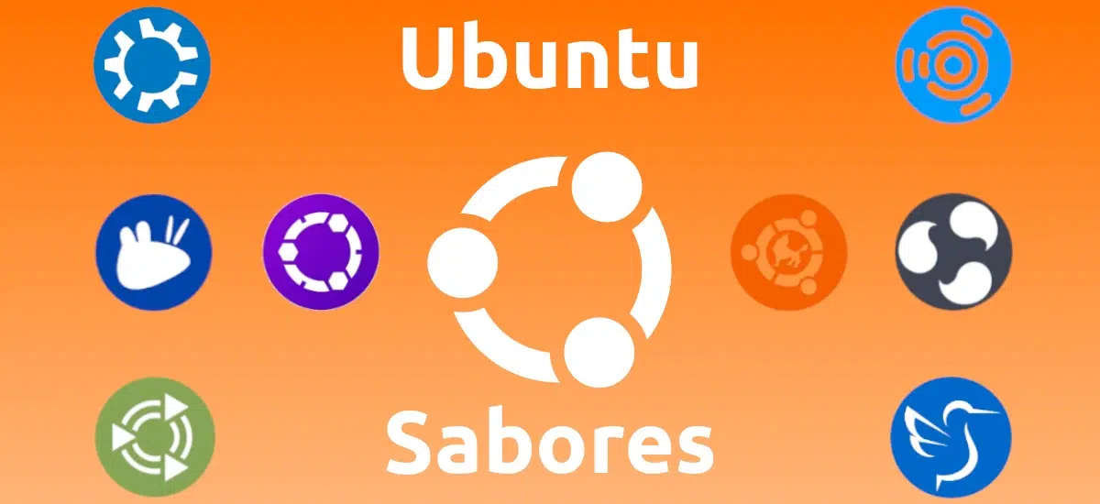

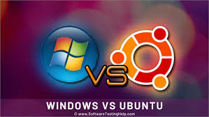

# 3. Difference between Ubuntu and Windows OS

|  |  |
| --- | --- |
| Ubuntu | Windows |
| Free and open-source | Requires paid license |
| Based on Linux kernel | Based on NT kernel |
| Uses GNOME desktop environment | Uses taskbar and start menu |
| APT package manager for installation | Uses .exe and .msi installers |
| More secure, less prone to malware | More vulnerable to malware |
| Efficient on older hardware | Resource-intensive, needs modern hardware |
| Multiple desktop environment options | Fixed Windows interface with fewer customization options |
| Frequent and free updates | Windows updates may require license upgrades |
| Better suited for development and servers | Popular for gaming and office environments |
| Command-line friendly | Graphical interface-centric, with limited CLI use |

Key Differences Explained:

• Cost: Ubuntu is free and open-source, while Windows requires a paid license.  
• Kernel: Ubuntu is based on the Linux kernel, offering stability and performance, whereas Windows uses the NT kernel.  
• User Interface: Ubuntu uses the GNOME desktop environment, which is highly customizable, while Windows has a more rigid and standardized interface.  
• Software Management: Ubuntu uses the APT package manager for easy installation of applications, while Windows relies on .exe and .msi installers.  
• Security: Ubuntu is generally more secure by design, with fewer vulnerabilities, while Windows is more prone to malware attacks.  
• Hardware Compatibility: Ubuntu runs efficiently on older hardware, making it a cost-effective option, while Windows requires more modern and powerful hardware for smooth performance.  
• Customization: Ubuntu allows users to change the desktop environment, while Windows offers limited customization.  
• Usage: Ubuntu is popular for development, servers, and cloud environments, while Windows is more common for gaming and office use.